Justin Newman

ENG135-03

12/5/2012

How to Assemble a Desktop Computer

I am a self-employed computer technician and most of the work I do involves troubleshooting software on peoples’ computers, however, what I love to do is build computers. I’ve hand built my last three computers, and have built many more for customers of mine. When I tell people “Yes, I build computers” they are generally very impressed, as if I were a neurosurgeon or something; if only they knew how easy it is!

Congratulations on your decision to build your own computer! The following guide will walk you through the process of assembling the hardware of your new computer.

The first task will be to select and purchase the components for your computer.

Note 1: When selecting components for your computer, it is essential that you pay close attention to the description of the various parts. The motherboard and CPU interface via a special “socket”, thus you must ensure that your CPU and motherboard use the same socket and that the motherboard supports the model of CPU chosen. (All compatibility information can be found on the motherboard manufacturer’s website)

Materials Required:

|  |  |
| --- | --- |
| 1. Processor (CPU)\*   \*(See Note 1) | C:\Users\Der Meister\Desktop\School\ENG135\Project 5\Processor.png |
| 1. Motherboard (MB)\*   \*(See Note 1) | C:\Users\Der Meister\Desktop\School\ENG135\Project 5\motherboard.png |
| (1-8)Memory (RAM)\*  \*Ensure that the you select memory of the same type and capacity supported by the motherboard | C:\Users\Der Meister\Desktop\School\ENG135\Project 5\memory.png |
| (1)Power Supply (PSU)  PSUs are rated by output (Watts), 500w is sufficient for a mid-range computer, though, if you choose to add multiple hard-disk drives and/or a powerful graphics card, you’ll need a more powerful PSU as well. | C:\Users\Der Meister\Desktop\School\ENG135\Project 5\psu.png |
| (1)Computer Case  Ensure your case can fit your motherboard. Cases are rated by what size (or “form factor”) motherboard they can accommodate. Common sizes are ATX or full ATX (larger, more connections), MicroATX (mid-sized, affordable), and MiniITX (small, energy efficient). Any case that supports full ATX can support the smaller two. But a MicroATX case will not accommodate the larger full ATX boards. | C:\Users\Der Meister\Desktop\School\ENG135\Project 5\computer.png |
| (1+) Hard-Disk Drive(HDD) or Solid State Drive(SSD)\*  Modern storage drives come in two varieties, HDDs have spinning disks inside of them, have higher capacities, and are significantly cheaper than SSDs. SSDs on the other hand, are incredibly fast, extremely power efficient, but also quite expensive compared to HDDs. | C:\Users\Der Meister\Desktop\School\ENG135\Project 5\hdd.png |
| (1)CPU Cooler (if not included with processor) + Thermal Paste (if not included with CPU Cooler) | C:\Users\Der Meister\Desktop\School\ENG135\Project 5\cooler.png  C:\Users\Der Meister\Desktop\School\ENG135\Project 5\TIM.png |
| Optical Drive (CD/DVD/Blu-Ray) | C:\Users\Der Meister\Desktop\School\ENG135\Project 5\odd.png |
| Cooling Fan(s) | C:\Users\Der Meister\Desktop\School\ENG135\Project 5\fan.png |
| Cables for connecting HDD(s) and Optical Drive(s)  SATA is the standard interface for internal computer drives, and new drives usually come packaged with the necessary cables. If cables are not provided, they can be purchased at any online, and most brick-and-mortar, electronics retailers. | C:\Users\Der Meister\Desktop\School\ENG135\Project 5\sata.png |
| Graphics/Video Card (GPU) (Optional if motherboard is equipped with built-in graphics) | C:\Users\Der Meister\Desktop\School\ENG135\Project 5\gpu.png |
| Screws (these will be supplied with your computer case) |  |
| Phillips screwdriver |  |
| Scissors (for opening packaging) |  |
|  |  |
| OPTIONAL |  |
| Zip-Ties (and snips for trimming the excess of the ties) |  |
| Lighted fans |  |

Types of screws

|  |  |  |
| --- | --- | --- |
| Case Screw | Drive Screw | Fan Screw |
| C:\Users\Der Meister\Desktop\School\ENG135\Project 5\cs.png | C:\Users\Der Meister\Desktop\School\ENG135\Project 5\ds.png | C:\Users\Der Meister\Desktop\School\ENG135\Project 5\fs.png |

Step 1:

In a large, clean, well-lit, and static electricity free workspace, un-package the motherboard and lay it on the anti-static bag it was packaged in. Un-package the CPU, CPU cooler, and memory at this time and set them near your motherboard. Set all other parts aside, also set aside the rectangular I/O panel and any other documentation included with the motherboard. You’ll need to motherboard documentation later, so don’t let it get too far!

Step 2:

Locate the CPU socket on the motherboard, remove any protective covers, and disengage the CPU retention mechanism. Remove the CPU from its protective plastic and insert it aluminum heat-spreader side up, into the CPU socket on the motherboard, taking care to align the notches in the CPU with the corresponding ridges in the CPU socket. Once the CPU is properly inserted into the socket, re-engage the retention mechanism.

|  |  |  |
| --- | --- | --- |
| C:\Users\Der Meister\Desktop\School\ENG135\Project 5\sckt1.png  Figure : CPU Socket | C:\Users\Der Meister\Desktop\School\ENG135\Project 5\cpuckt2.png  Figure : CPU aligned and set in socket | C:\Users\Der Meister\Desktop\School\ENG135\Project 5\cpusckt3.png  Figure : CPU retention mechanism re-engaged |

.

Step 3:

Now, insert the RAM into the long, narrow memory slots on the motherboard. First, disengage the retaining clips at each end of the slot by pushing them outward. Next, insert the sticks of RAM, taking care to align the notch in the connecting edge with the corresponding ridge or “key” in each RAM slot. After inserting the RAM into its slots, push the retaining clips inward to lock the memory in place.

|  |  |  |
| --- | --- | --- |
| C:\Users\Der Meister\Desktop\School\ENG135\Project 5\mem1.png  Figure : Notch in RAM aligned with “key” in slot | C:\Users\Der Meister\Desktop\School\ENG135\Project 5\mem2.png  Figure : Retention clips retracted | C:\Users\Der Meister\Desktop\School\ENG135\Project 5\mem3.png  Figure : Retention clip engaged |

Step 4:

Now you should install the CPU cooler; different brands of cooler use different mounting methods, and the instructions accompanying the cooler should walk you through the process. If the CPU cooler does not have thermal paste or grease installed on the surface where it contacts the CPU, you will need to apply some to the top of the CPU. When applying thermal paste, take EXTREME care not to get it anywhere but the top surface of the CPU; many thermal greases are electrically conductive and can damage your computer if applied in excess or improperly. The ideal amount of thermal paste on a processor is just enough so that, when spread in a thin, semi-opaque layer, it just covers the entire top surface of the CPU. The proper application method is shown below:

|  |  |  |
| --- | --- | --- |
| C:\Users\Der Meister\Desktop\School\ENG135\Project 5\tg1.png  Figure : Begin application of thermal grease | C:\Users\Der Meister\Desktop\School\ENG135\Project 5\tg2.png  Figure : Thermal grease applied and spread over the heat spreader | C:\Users\Der Meister\Desktop\School\ENG135\Project 5\cooler2.png  Figure : CPU cooler installed. Note 4pin CPU-fan connector at bottom |

NOTE: Take care not to get any dust or fur on the CPU or in the thermal paste during application or installation of the CPU cooler.

Pay attention to where the fan power/speed control plugs into the motherboard, you should ensure that the CPU cooler is oriented to leave enough slack to reach the fan speed/control connector.

At this point you should have something like this: 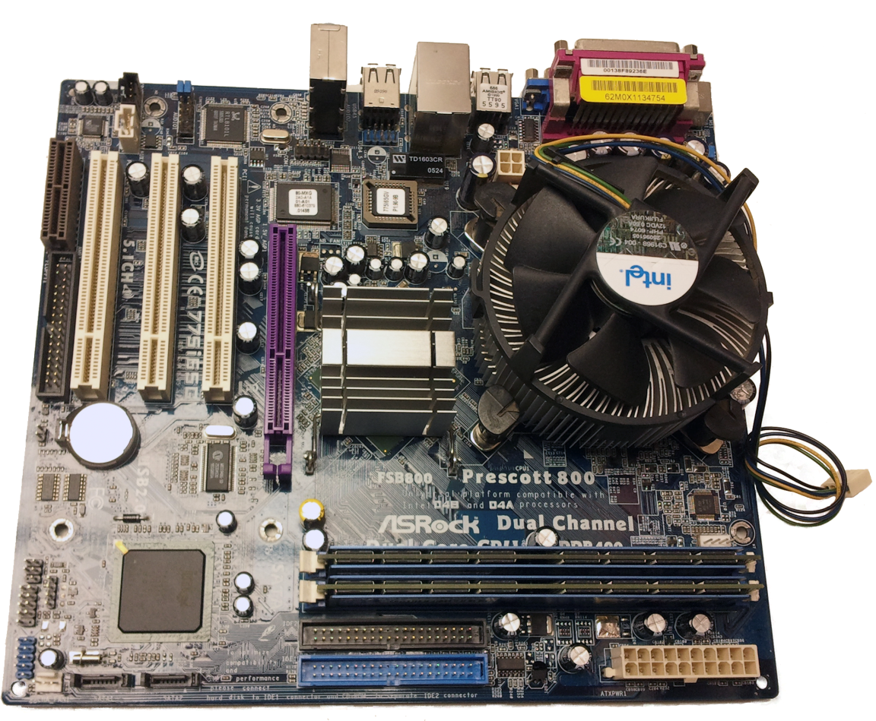

Step 5:

With the motherboard, CPU, and RAM assembled, it is time to set them aside and begin assembling the case, HDD(s), optical drive(s), and power supply. First, remove the case from the box it came in, locate the included packet of screws and other hardware, and set them aside. Next, remove the power supply (PSU) from its packaging, locate the small packet of mounting screws, and set both aside. Then, remove the side panel of the case to gain access to its interior, locate the opening in the rear of the case for the power supply, orient the PSU so that any fans are not obstructed, and then mount the PSU using the supplied packet of screws.

|  |  |
| --- | --- |
| C:\Users\Der Meister\Desktop\School\ENG135\Project 5\psu.png  Figure : PSU Installed | C:\Users\Der Meister\Desktop\School\ENG135\Project 5\psu2.png  Figure : Screws used to install PSU |

Install fans (if any) into corresponding openings in the case. The fan screws will be driven directly into the small holes at each corner of the fan, ensuring the fan is facing in the desired direction of airflow. When installing fans, ensure that screws are driven in straight and slowly, this will prevent you from cracking or breaking the screw holes.

|  |  |
| --- | --- |
| C:\Users\Der Meister\Desktop\School\ENG135\Project 5\faninstall1.png  Figure : Fan screws properly aligned | C:\Users\Der Meister\Desktop\School\ENG135\Project 5\faninstall2.png  Figure : Fans installed |

|  |  |
| --- | --- |
| C:\Users\Der Meister\Desktop\School\ENG135\Project 5\hddc.png  Figure : SATA hard-disk drive with power and data cables connected | C:\Users\Der Meister\Desktop\School\ENG135\Project 5\toolless.png  Figure : Example of tool-less optical drive retention mechanism |

Now, un-package and install the optical and Hard/Solid-State drives. When installing the optical drive, you may have to remove a panel or “blank” from the bay in which you want to install the drive, you’re case should include instructions for the installation of your various drives. If screws are required, most drives use the finer-threaded “drive screws”.

Step 6:

With the power supply installed, it is time to install the motherboard. Install the I/O panel that was included with the motherboard into corresponding opening in the rear of the case.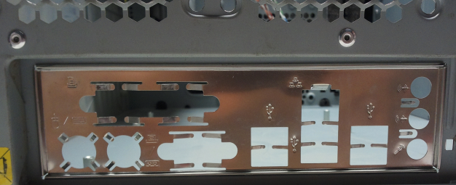

Figure : I/O Panel installed

Next, install motherboard spacers (if not pre-installed) into openings in the motherboard tray that correspond to the screw-holes in the motherboard (shown below). Finally, align the rear-panel connectors on the motherboard with the I/O panel you installed in the case, install the motherboard, and screw it down (the motherboard will almost always be installed using “case” type screws, ).

|  |  |
| --- | --- |
| C:\Users\Der Meister\Desktop\School\ENG135\Project 5\tray.png  Figure : Motherboard tray with stand-offs visible | C:\Users\Der Meister\Desktop\School\ENG135\Project 5\mbintray.png  Figure : Motherboard installed in case |

Note: Depending on your case, you may have a removable module to install your hard/solid-state drives in; in this case, you’ll install the drives in the module at this step and install the module into the case after you’ve installed the motherboard/CPU/RAM assembly.

Step 7:

Make all of your internal connections and route the wires in neat bundles (if possible, secure using zip-ties) There will be cabling coming from the buttons and any connectors at the front of the case (USB, Audio, etc.), there will be a diagram included with your motherboard that shows how each of these connections are made. Take note of the “+” and “–“ symbols printed on the connectors for the front buttons and LEDs, as they will help you to connect everything properly. 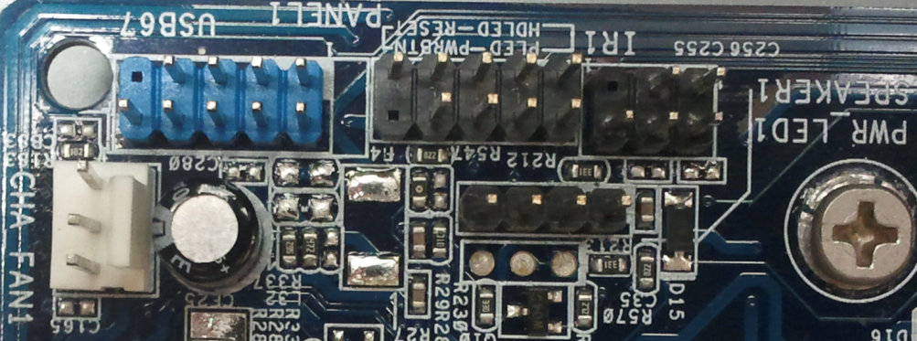

Figure : Headers for front buttons, LEDs, and USB ports

As always, when in doubt check the manufacturer’s website or documentation.

Most new Optical and Hard Disk/Solid State drives use a technology called Serial ATA (SATA) to connect to the motherboard; these connectors are thin and about ½ in. wide, with a small block or “key” to ensure proper orientation when connected.

The power supply will have a several different types of connectors coming from it, these can be divided into two groups:

PSU-to-Motherboard Connections

|  |  |
| --- | --- |
| C:\Users\Der Meister\Desktop\School\ENG135\Project 5\mbpwr.png  Figure : 20/24-pin motherboard main power connection | C:\Users\Der Meister\Desktop\School\ENG135\Project 5\cpupwr.png  Figure : 4/8-pin "ATX" power connection (connects near CPU) |

The above connectors go from the PSU to the motherboard and power the motherboard, CPU, and other onboard devices. Both of these connectors offer the ability to separate pins that will remain unused in certain applications (mostly when used with older motherboards and CPUs).

PSU-to-Device Connections

|  |  |  |
| --- | --- | --- |
| C:\Users\Der Meister\Desktop\School\ENG135\Project 5\molex.png  Figure : 4 pin "molex" connector | C:\Users\Der Meister\Desktop\School\ENG135\Project 5\satapwr.png  Figure : 15 pin SATA connector | C:\Users\Der Meister\Desktop\School\ENG135\Project 5\pcie.png  Figure : 6 (may also be 8) pin PCI Express connector |

The above three connectors power various devices in your computer, and each has its own use. The molex connector used to be used for hard-disk and optical drives, however, it has largly been replaced by the newer SATA connector in that application. Today, the molex connector is mostly used for fans and other lower-power auxiliary devices. The 15 pin SATA connector is the standard power connector for nearly all modern hard-disk, solid-state, and optical drives, the few exceptions being drives that are manufactured for use in “legacy” systems where new technology is incompatible. The 6 or 8 pin PCI Express connector is designed primarily to supply large amounts of energy to power-hungry high-end graphics cards that are unable to get enough power from the other connectors.

Your build should look similar to this by now:

|  |
| --- |
| C:\Users\Der Meister\Desktop\School\ENG135\Project 5\IMG_20121209_002118.jpg  Figure : Your build should look something like this. Note the excess cabling tucked below the optical drive |
| C:\Users\Der Meister\Desktop\School\ENG135\Project 5\IMG_20121209_024045.jpg  Figure : If using zip-ties, something like this can be achieved. Note how the wiring is in neat bundles and does not obstruct airflow through the case. |

Step 8:

Reinstall side panel of case. Voila! You’ve just built your first computer! Now, all that remains is to hook it up to peripherals of your choice, install your favorite operating system, and enjoy your handiwork for years to come.

If Libby can do it, so can You!